RNN Intro

https://www.analyticsvidhya.com/blog/2022/03/a-brief-overview-of-recurrent-neural-networks-rnn/
https://www.analyticsvidhya.com/blog/2017/12/introduction-to-recurrent-neural-networks/

Need for a Neural Network dealing with Sequences
Before we deep dive into the details of what a recurrent neural network is, let’s ponder a bit on if we really need a network specially for dealing with sequences in information. Also what are kind of tasks that we can achieve using such networks.
The beauty of recurrent neural networks lies in their diversity of application. When we are dealing with RNNs they have a great ability to deal with various input and output types.
- Sentiment Classification – This can be a task of simply classifying tweets into positive and negative sentiment. So here the input would be a tweet of varying lengths, while output is of a fixed type and size.
- Image Captioning – Here, let’s say we have an image for which we need a textual description. So we have a single input – the image, and a series or sequence of words as output. Here the image might be of a fixed size, but the output is a description of varying lengths
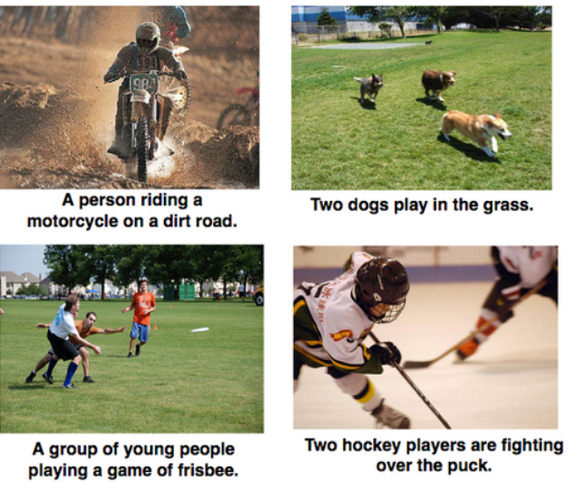
- Language Translation – This basically means that we have some text in a particular language let’s say English, and we wish to translate it in French. Each language has it’s own semantics and would have varying lengths for the same sentence. So here the inputs as well as outputs are of varying lengths.

So RNNs can be used for mapping inputs to outputs of varying types, lengths and are fairly generalized in their application. Looking at their applications, let’s see how the architecture of an RNN looks like.
What are Recurrent Neural Networks?
Let’s say the task is to predict the next word in a sentence. Let’s try accomplishing it using an MLP. So what happens in an MLP. In the simplest form, we have an input layer, a hidden layer and an output layer. The input layer receives the input, the hidden layer activations are applied and then we finally receive the output.
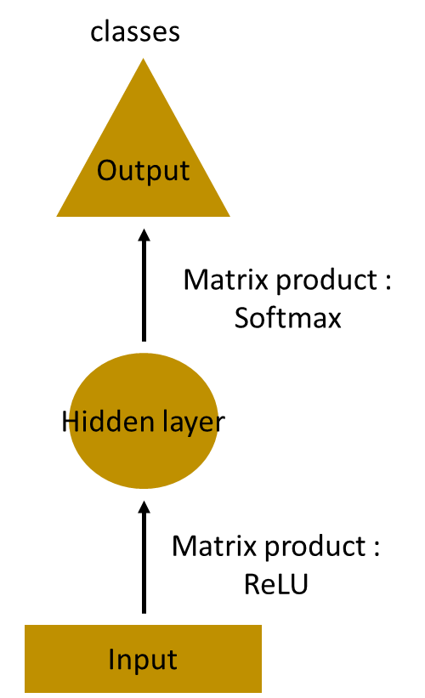
Let’s have a deeper network, where multiple hidden layers are present. So here, the input layer receives the input, the first hidden layer activations are applied and then these activations are sent to the next hidden layer, and successive activations through the layers to produce the output. Each hidden layer is characterized by its own weights and biases.
Since each hidden layer has its own weights and activations, they behave independently. Now the objective is to identify the relationship between successive inputs. Can we supply the inputs to hidden layers? Yes we can!
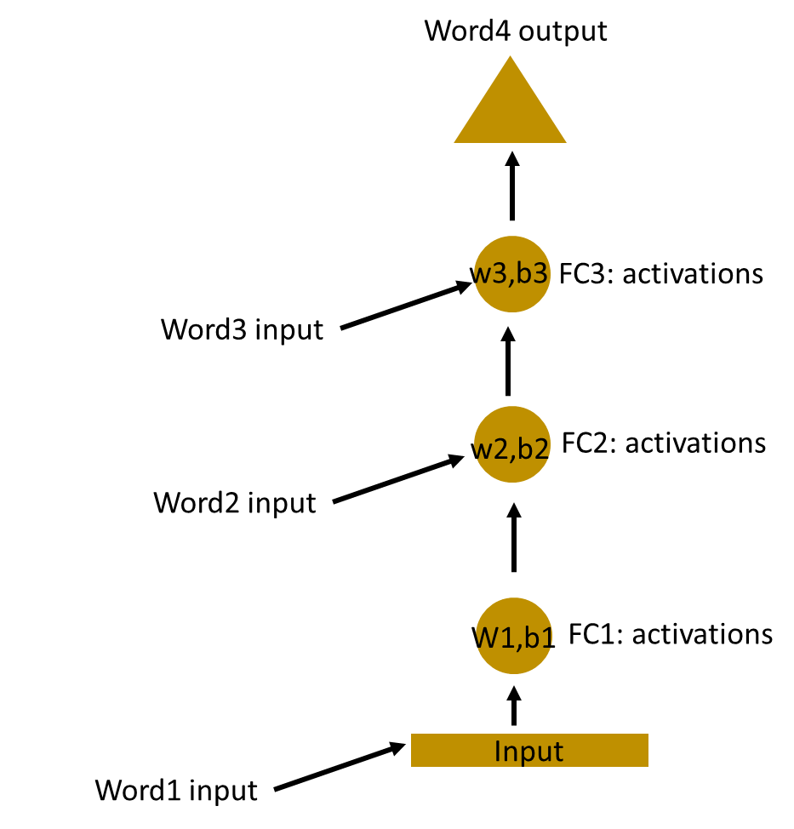
Here, the weights and bias of these hidden layers are different. And hence each of these layers behave independently and cannot be combined together. To combine these hidden layers together, we shall have the same weights and bias for these hidden layers.
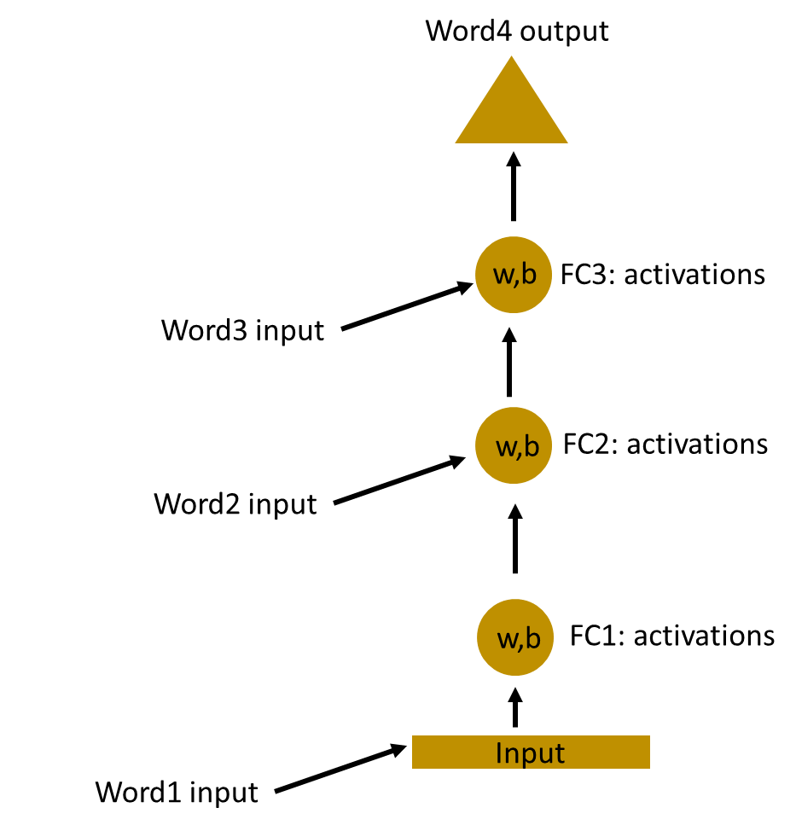
We can now combines these layers together, that the weights and bias of all the hidden layers is the same. All these hidden layers can be rolled in together in a single recurrent layer.
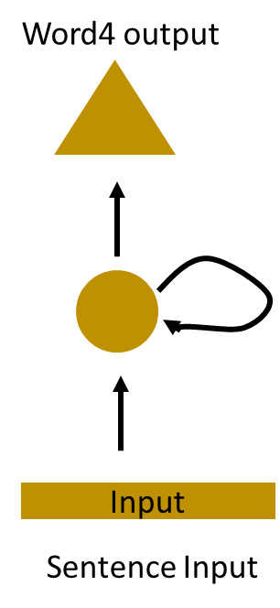
So it’s like supplying the input to the hidden layer. At all the time steps weights of the recurrent neuron would be the same since its a single neuron now. So a recurrent neuron stores the state of a previous input and combines with the current input thereby preserving some relationship of the current input with the previous input.
Understanding a Recurrent Neuron in Detail
Let’s take a simple task at first. Let’s take a character level RNN where we have a word “Hello”. So we provide the first 4 letters i.e. h,e,l,l and ask the network to predict the last letter i.e.’o’. So here the vocabulary of the task is just 4 letters {h,e,l,o}. In real case scenarios involving natural language processing, the vocabularies include the words in entire wikipedia database, or all the words in a language. Here for simplicity we have taken a very small set of vocabulary.
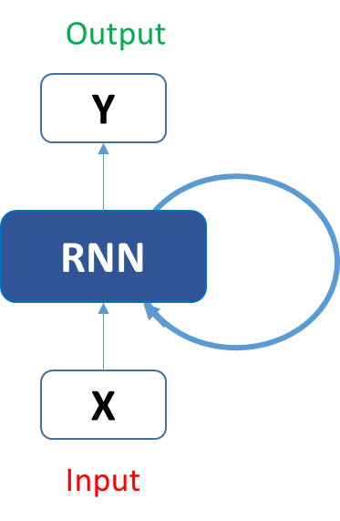
Let’s see how the above structure be used to predict the fifth letter in the word “hello”. In the above structure, the blue RNN block, applies something called as a recurrence formula to the input vector and also its previous state. In this case, the letter “h” has nothing preceding it, let’s take the letter “e”. So at the time the letter “e” is supplied to the network, a recurrence formula is applied to the letter “e” and the previous state which is the letter “h”. These are known as various time steps of the input. So if at time t, the input is “e”, at time t-1, the input was “h”. The recurrence formula is applied to e and h both. and we get a new state.
The formula for the current state can be written as –
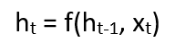
Here, Ht is the new state, ht-1 is the previous state while xt is the current input. We now have a state of the previous input instead of the input itself, because the input neuron would have applied the transformations on our previous input. So each successive input is called as a time step.
In this case we have four inputs to be given to the network, during a recurrence formula, the same function and the same weights are applied to the network at each time step.
Taking the simplest form of a recurrent neural network, let’s say that the activation function is tanh, the weight at the recurrent neuron is Whh and the weight at the input neuron is Wxh, we can write the equation for the state at time t as –
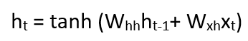
The Recurrent neuron in this case is just taking the immediate previous state into consideration. For longer sequences the equation can involve multiple such states. Once the final state is calculated we can go on to produce the output
Now, once the current state is calculated we can calculate the output state as-
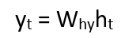
Let me summarize the steps in a recurrent neuron for you-
- A single time step of the input is supplied to the network i.e. xt is supplied to the network
- We then calculate its current state using a combination of the current input and the previous state i.e. we calculate ht
- The current ht becomes ht-1 for the next time step
- We can go as many time steps as the problem demands and combine the information from all the previous states
- Once all the time steps are completed the final current state is used to calculate the output yt
- The output is then compared to the actual output and the error is generated
- The error is then backpropagated to the network to update the weights(we shall go into the details of backpropagation in further sections) and the network is trained
Let’s take a look of how we can calculate these states in Excel and get the output.
Forward Propagation in a Recurrent Neuron in Excel
Let’s take a look at the inputs first –
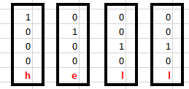
The inputs are one hot encoded. Our entire vocabulary is {h,e,l,o} and hence we can easily one hot encode the inputs.
Now the input neuron would transform the input to the hidden state using the weight wxh. We have randomly initialized the weights as a 3*4 matrix –
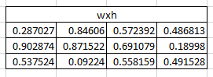
Step 1:
Now for the letter “h”, for the the hidden state we would need Wxh*Xt. By matrix multiplication, we get it as –
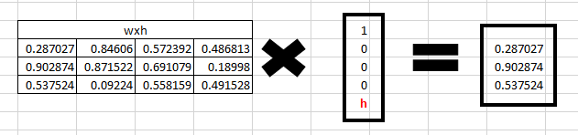
Step 2:
Now moving to the recurrent neuron, we have Whh as the weight which is a 1*1 matrix as 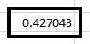 and the bias which is also a 1*1 matrix as 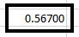
For the letter “h”, the previous state is [0,0,0] since there is no letter prior to it.
So to calculate -> (whh*ht-1+bias)
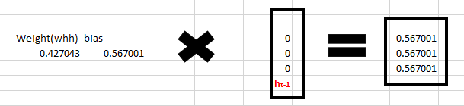
Step 3:
Now we can get the current state as –

Since for h, there is no previous hidden state we apply the tanh function to this output and get the current state –
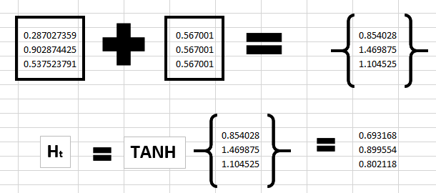
Step 4:
Now we go on to the next state. “e” is now supplied to the network. The processed output of ht, now becomes ht-1, while the one hot encoded e, is xt. Let’s now calculate the current state ht.

Whh*ht-1 +bias will be –
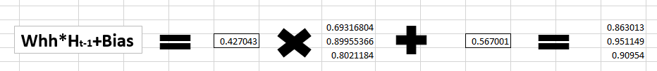
Wxh*xt will be –
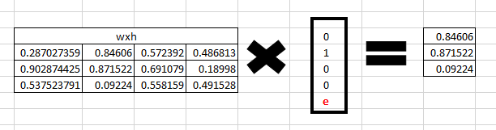
Step 5:
Now calculating ht for the letter “e”,
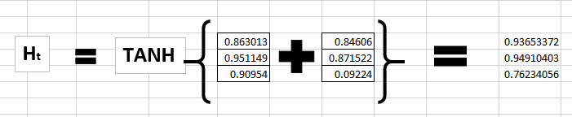
Now this would become ht-1 for the next state and the recurrent neuron would use this along with the new character to predict the next one.
Step 6:
At each state, the recurrent neural network would produce the output as well. Let’s calculate yt for the letter e.
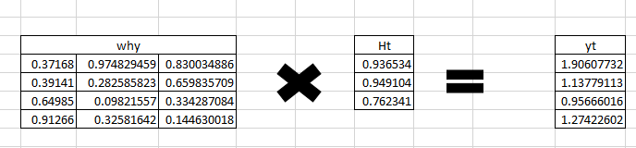
Step 7:
The probability for a particular letter from the vocabulary can be calculated by applying the softmax function. so we shall have softmax(yt)
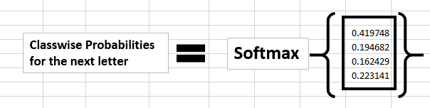
If we convert these probabilities to understand the prediction, we see that the model says that the letter after “e” should be h, since the highest probability is for the letter “h”. Does this mean we have done something wrong? No, so here we have hardly trained the network. We have just shown it two letters. So it pretty much hasn’t learnt anything yet.
Now the next BIG question that faces us is how does Back propagation work in case of a Recurrent Neural Network. How are the weights updated while there is a feedback loop?

Understanding Recurrent Neural Network (RNN)
Recurrent Neural Networks imitate the function of the human brain in the fields of Data science, Artificial intelligence, machine learning, and deep learning, allowing computer programs to recognize patterns and solve common issues.
RNNs are a type of neural network that can model sequence data. RNNs, which are formed from feedforward networks, are similar to human brains in their behaviour. Simply said, recurrent neural networks can anticipate sequential data in a way that other algorithms can’t.
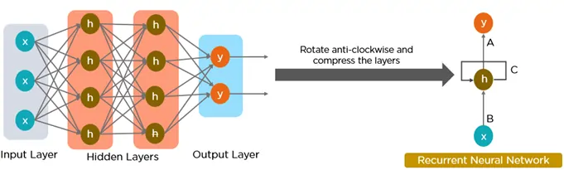
All of the inputs and outputs in standard neural networks are independent of one another. However, in some circumstances, such as when predicting the next word of a phrase, the prior words are necessary, and so the previous words must be remembered. As a result, RNN was created, which used a hidden layer to overcome the problem. The most important component of RNN is the hidden state, which remembers specific information about a sequence.
RNNs have a Memory that stores all information about the calculations. They employ the same settings for each input since they produce the same outcome by performing the same task on all inputs or hidden layers.
Also Read: Introduction to Autoencoders
What Makes RNN Special?
Recurrent Neural Networks (RNNs) set themselves apart from other neural networks with their unique capabilities:
- Internal Memory: This is the key feature of RNNs. It allows them to remember past inputs and use that context when processing new information.
- Sequential Data Processing: Because of their memory, RNNs are exceptional at handling sequential data where the order of elements matters. This makes them ideal for speech recognition, machine translation, natural language processing (NLP), and text generation.
- Contextual Understanding: RNNs can analyze the current input about what they’ve “seen” before. This contextual understanding is crucial for tasks where meaning depends on prior information.
- Dynamic Processing: RNNs can continuously update their internal memory as they process new data, allowing them to adapt to changing patterns within a sequence.
Also Read: Introduction to Convolution Neural Networks
RNN Architecture
RNNs are a type of neural network that have hidden states and allow past outputs to be used as inputs. They usually follow a certain architecture. One example is the Deep RNN: by stacking multiple RNN layers on top of each other, deep RNNs create a more complex architecture. This allows them to capture intricate relationships within very long sequences of data. They are particularly useful for tasks where the order of elements spans long stretches.
Here’s a breakdown of its key components:
- Input Layer: This layer receives the initial element of the sequence data. For example, in a sentence, it might receive the first word as a vector representation.
- Hidden Layer: The heart of the RNN, the hidden layer contains a set of interconnected neurons. Each neuron processes the current input along with the information from the previous hidden layer’s state. This “state” captures the network’s memory of past inputs, allowing it to understand the current element in context.
- Activation Function: This function introduces non-linearity into the network, enabling it to learn complex patterns. It transforms the combined input from the current input layer and the previous hidden layer state before passing it on.
- Output Layer: The output layer generates the network’s prediction based on the processed information. In a language model, it might predict the next word in the sequence.
- Recurrent Connection: A key distinction of RNNs is the recurrent connection within the hidden layer. This connection allows the network to pass the hidden state information (the network’s memory) to the next time step. It’s like passing a baton in a relay race, carrying information about previous inputs forward
Architecture of a Traditional RNN
RNNs are a type of neural network with hidden states and allow past outputs to be used as inputs. They usually go like this:
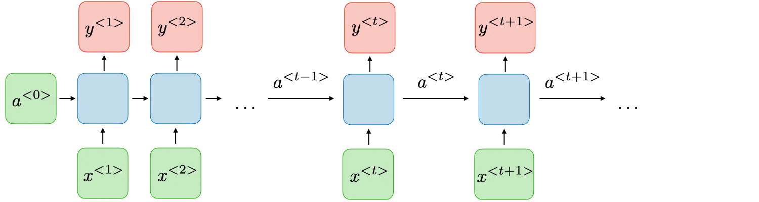
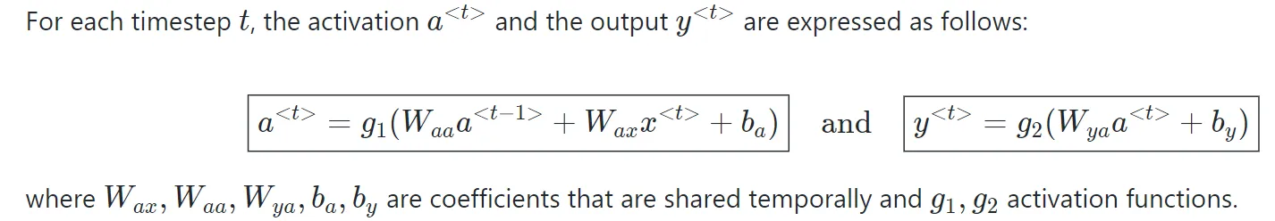
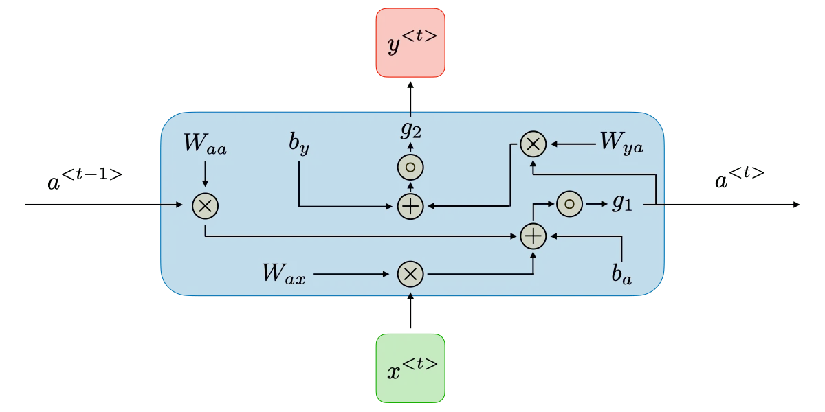
RNN architecture can vary depending on the problem you’re trying to solve. It can range from those with a single input and output to those with many (with variations between).
Below are some RNN architectures that can help you better understand this.
- One-to-One: There is only one pair here. A one-to-one architecture is used in traditional neural networks.
- One-to-Many: A single input in a one-to-many network might result in numerous outputs. One too many networks are used in music production, for example.
- Many-to-one: A single output combines inputs from distinct time steps in this scenario. Sentiment analysis and emotion identification use such networks, in which a sequence of words determines the class label.
- Many-to-Many: For many-to-many, there are numerous options. Input and output are sequences of potentially different lengths. Machine translation systems, such as English to French or vice versa translation systems, use many-to-many networks.

Types of RNN
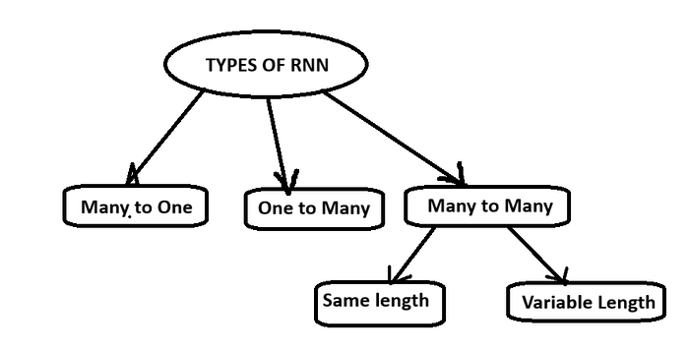

1. Many to One:
Input : Takes a sequential data like sentence, char, or time series data etc
Output : Gives a non sequential data like int, num (scalars)
Example : Sentiment Analysis, Rating prediction
It is called as many to one because it contains multiple inputs and only a single output
Architecture:
Press enter or click to view image in full size
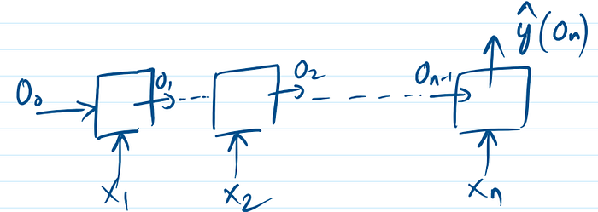
Many to One Architecture

2. One to Many:
Input : Takes non sequential data like int, image etc
Output : Gives a sequential data
Example : Image Captioning
It is called as one to many because it contains single input and gives multiple outputs
Architecture:
Press enter or click to view image in full size
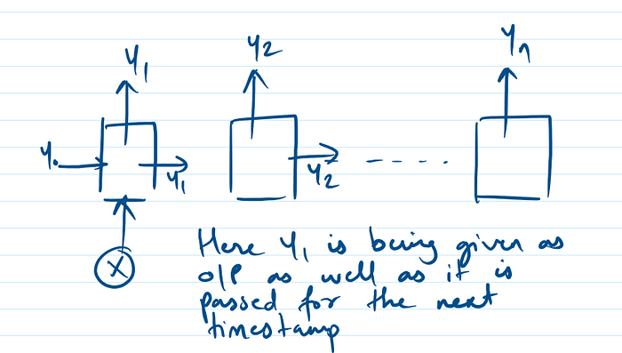
One to Many architecture

3. Many to Many (also called as seq2seq):
Input : Takes sequential data
Output : Gives a sequential data
Example : Question answering system, chatbot, music generation via text
It is called as many to many because it takes multiple input and gives multiple outputs.
Now this is further divided into same length and variable length
Same length : input size = output size. Example : parts of speech tagging, named entity recognition(NER)
Architecture:
Press enter or click to view image in full size
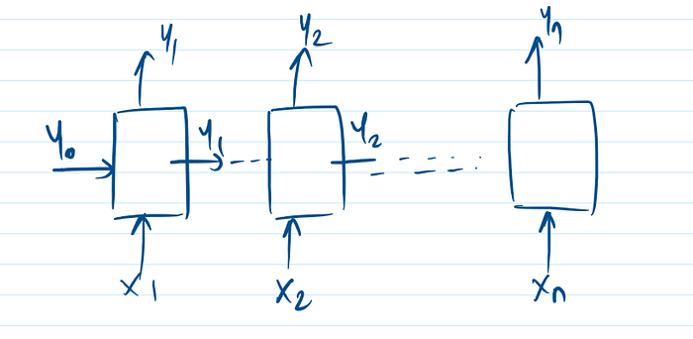
Same length many to many architecture
Variable length : input size is not equal to output size .Example : machine translation like translating one language to another. lets say to translate English to Hindi. Sentence in English is lets run In Hindi this will be written as chalo bhagte hai . Here the size of the input is different as compared to output. Another example can be CHATGPT.
Architecture:
Press enter or click to view image in full size
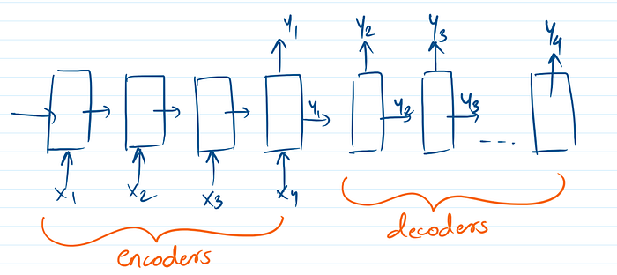
variable length many to many architecture

4. One to One:
Technically speaking it is not one to one architecture. Since its input and output both will be non sequential data. Example of to one to one type of RNN will be image classification, ANN, CNN.

So there are only 3 types of RNN : One to Many, Many to One, Many to Many (same length, variable length)

How do Recurrent Neural Networks Work?
The information in recurrent neural networks cycles through a loop to the middle hidden layer.
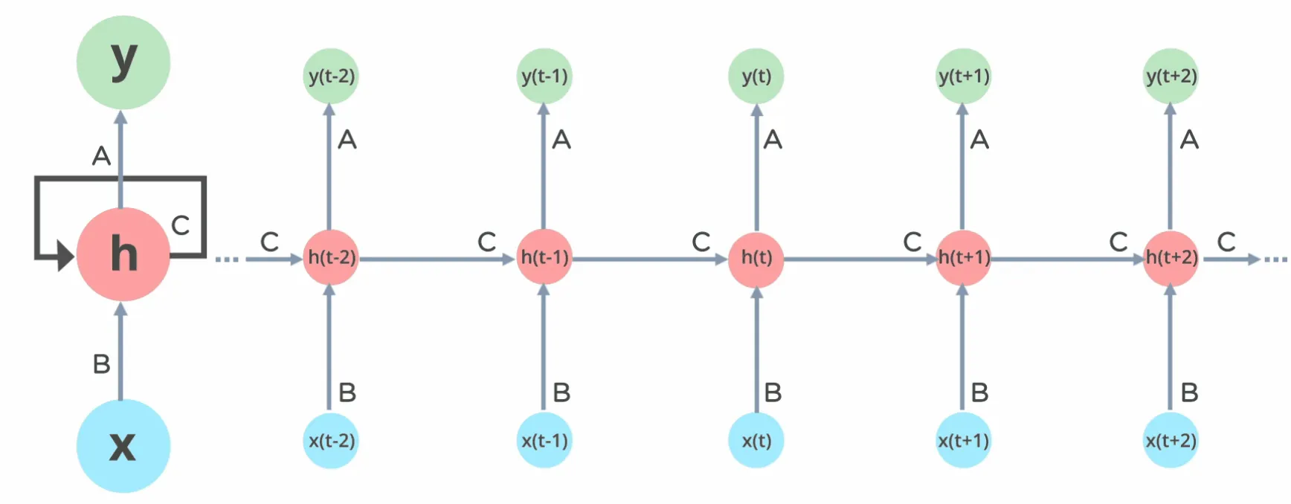
The input layer x receives and processes the neural network’s input before passing it on to the middle layer.
In the middle layer h, multiple hidden layers can be found, each with its activation functions, weights, and biases. There’s a single hidden layer that repeats over time steps. The same weights are used across all steps. The hidden state is updated recursively using the current input and the previous hidden state.
The recurrent neural network will standardize the different activation functions, weights, and biases, ensuring that each hidden layer has the same characteristics. Rather than constructing numerous hidden layers, it will create only one and loop over it as many times as necessary.
Recurrent Neural Network vs Feed-forward Neural Network
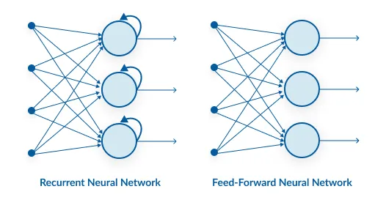

Feature | Feed-forward Neural Network (FNN) | Recurrent Neural Network (RNN)
Data Flow | Straight through (no loops) | Loops through time (with memory)
Memory | No memory of past inputs | Maintains memory via hidden states
Input Assumption | Inputs are independent | Inputs are sequentially dependent
Architecture | Static layers, no time dimension | Unfolds across time steps
Training | Standard backpropagation | Backpropagation Through Time (BPTT)

Back propagation in a Recurrent Neural Network(BPTT)
To imagine how weights would be updated in case of a recurrent neural network, might be a bit of a challenge. So to understand and visualize the back propagation, let’s unroll the network at all the time steps. In an RNN we may or may not have outputs at each time step.
In case of a forward propagation, the inputs enter and move forward at each time step. In case of a backward propagation in this case, we are figuratively going back in time to change the weights, hence we call it the Back propagation through time(BPTT).
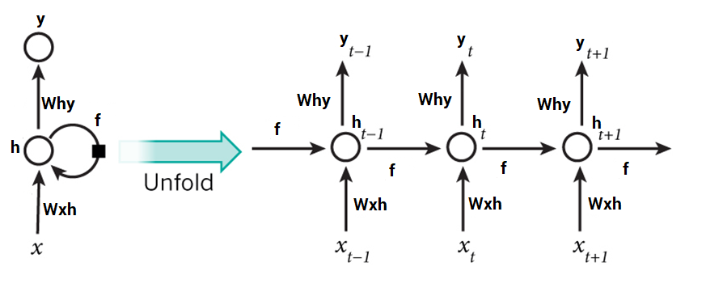
In case of an RNN, if yt is the predicted value ȳt is the actual value, the error is calculated as a cross entropy loss –
Et(ȳt,yt) = – ȳt log(yt)
E(ȳ,y) = – ∑ ȳt log(yt)
We typically treat the full sequence (word) as one training example, so the total error is just the sum of the errors at each time step (character). The weights as we can see are the same at each time step. Let’s summarize the steps for backpropagation
- The cross entropy error is first computed using the current output and the actual output
- Remember that the network is unrolled for all the time steps
- For the unrolled network, the gradient is calculated for each time step with respect to the weight parameter
- Now that the weight is the same for all the time steps the gradients can be combined together for all time steps
- The weights are then updated for both recurrent neuron and the dense layers
The unrolled network looks much like a regular neural network. And the back propagation algorithm is similar to a regular neural network, just that we combine the gradients of the error for all time steps. Now what do you think might happen, if there are 100s of time steps. This would basically take really long for the network to converge since after unrolling the network becomes really huge.
In case you do not wish to deep dive into the math of backpropagation, all you need to understand is that back propagation through time works similar as it does in a regular neural network once you unroll the recurrent neuron in your network. However, I shall be coming up with a detailed article on Recurrent Neural networks with scratch with would have the detailed mathematics of the backpropagation algorithm in a recurrent neural network.
Implementation of Recurrent Neural Networks in Keras
Let’s use Recurrent Neural networks to predict the sentiment of various tweets. We would like to predict the tweets as positive or negative. You can download the dataset here.
We have around 1600000 tweets to train our network. If you’re not familiar with the basics of NLP, I would strongly urge you to go through this article. We also have another detailed article on word embedding which would also be helpful for you to understand word embeddings in detail.
Let’s now use RNNs to classify various tweets as positive or negative.

Backpropagation Through Time (BPTT)
When we apply a Backpropagation algorithm to a Recurrent Neural Network with time series data as its input, we call it backpropagation through time.
In a normal RNN, a single input is sent into the network at a time, and a single output is obtained. On the other hand, backpropagation uses both the current and prior inputs as input. This is referred to as a timestep, and one timestep will consist of multiple time series data points entering the RNN simultaneously.
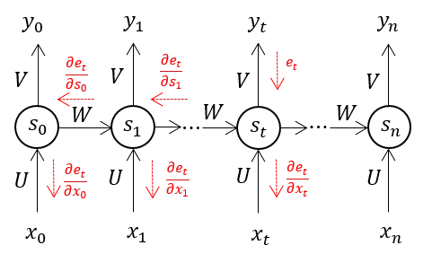
Once the neural network has trained on a set and given you an output, its output is used to calculate and collect the errors. The network is then rolled back up, and weights are recalculated and adjusted to account for the faults.
Two Issues of Standard RNNs
RNNs have had to overcome two key challenges, but to comprehend them, one must first grasp what a gradient is.
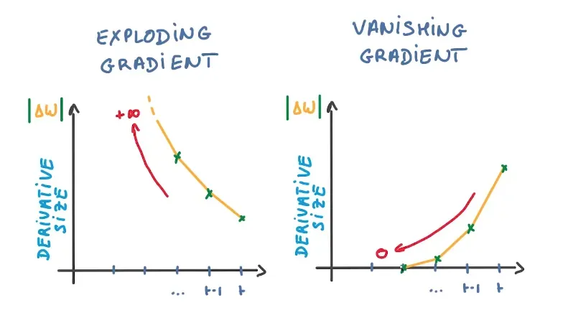
About its inputs, a gradient is a partial derivative. If you’re unsure what that implies, consider this: a gradient quantifies how much the output of a function varies when the inputs are changed slightly.
A function’s slope is also known as its gradient. The steeper the slope, the faster a model can learn, and the higher the gradient. The model, on the other hand, will stop learning if the slope is zero. A gradient is used to measure the change in all weights about the change in error.
- Exploding Gradients: Exploding gradients occur when the algorithm gives the weights an absurdly high priority for no apparent reason. Fortunately, truncating or squashing the gradients is a simple solution to this problem.
- Vanishing Gradients: Vanishing gradients occur when the gradient values are too small, causing the model to stop learning or take far too long. This was a big issue in the 1990s, and it was far more difficult to address than the exploding gradients. Fortunately, Sepp Hochreiter and Juergen Schmidhuber’s LSTM concept solved the problem.
What Are the Different Variations of RNN?
Researchers have introduced new, advanced RNN architectures to overcome issues like vanishing and exploding gradient descent that hinder learning in long sequences.
- Long Short-Term Memory (LSTM): A popular choice for complex tasks. LSTM networks introduce gates, i.e., input gate, output gate, and forget gate, that control the flow of information within the network, allowing them to learn long-term dependencies more effectively than vanilla RNNs.
- Gated Recurrent Unit (GRU): Similar to LSTMs, GRUs use gates to manage information flow. However, they have a simpler architecture, making them faster to train while maintaining good performance. This makes them a good balance between complexity and efficiency.
- Bidirectional RNN: This variation processes data in both forward and backward directions. This allows it to capture context from both sides of a sequence, which is useful for tasks like sentiment analysis where understanding the entire sentence is crucial.
- Deep RNN: Stacking multiple RNN layers on top of each other, deep RNNs create a more complex architecture. This allows them to capture intricate relationships within very long sequences of data. They are particularly useful for tasks where the order of elements spans long stretches.
RNN Applications
Recurrent neural networks (RNNs) shine in tasks involving sequential data, where order and context are crucial. Let’s explore some real-world use cases. Using RNN models and sequence datasets, you may tackle a variety of problems, including :
- Speech Recognition: RNNs power virtual assistants like Siri and Alexa, allowing them to understand spoken language and respond accordingly.
- Machine Translation: RNNs translate languages more accurately, like Google Translate by analysing sentence structure and context.
- Text Generation: RNNs are behind chatbots that can hold conversations and even creative writing tools that generate different text formats.
- Time Series Forecasting: RNNs analyze financial data to predict stock prices or weather patterns based on historical trends.
- Music Generation: RNNs can generate music by learning patterns from existing pieces and generating new melodies or accompaniments.
- Video Captioning: RNNs analyze video content and automatically generate captions, making video browsing more accessible.
- Anomaly Detection: RNNs can learn normal patterns in data streams (e.g., network traffic) and detect anomalies that might indicate fraud or system failures.
- Sentiment Analysis: RNNs can analyze sentiment in social media posts, reviews, or surveys by understanding the context and flow of text.
- Stock Market Recommendation: RNNs can analyze market trends and news to suggest potential investment opportunities.
- Sequence study of the genome and DNA: RNNs can analyze sequential data in genomes and DNA to identify patterns and predict gene function or disease risk.
Advantages and Disadvantages of RNNs
Advantages of RNNs | Disadvantages of RNNs
Handle sequential data effectively, including text, speech, and time series. | Prone to vanishing and exploding gradient problems, hindering learning.
Process inputs of any length, unlike feedforward neural networks. | Training can be challenging, especially for long sequences.
Share weights across time steps, enhancing training efficiency. | Computationally slower than other neural network architectures.
Basic Python Implementation (RNN with Keras)
Here’s a simple Sequential model that processes integer sequences, embeds each integer into a 64-dimensional vector, and then uses an LSTM layer to handle the sequence of vectors.
import numpy as np
import tensorflow as tf
from tensorflow import keras
from tensorflow.keras import layers

model = keras.Sequential()
model.add(layers.Embedding(input_dim=1000, output_dim=64))
model.add(layers.LSTM(128))
model.add(layers.Dense(10))
model.summary()
Output:
Model: "sequential"
_________________________________________________________________
Layer (type) Output Shape Param #
=================================================================
embedding (Embedding) (None, None, 64) 64000
_________________________________________________________________
lstm (LSTM) (None, 128) 98816
_________________________________________________________________
dense (Dense) (None, 10) 1290
=================================================================
Total params: 164,106
Trainable params: 164,106
Non-trainable params: 0
Conclusion
Recurrent Neural Networks (RNNs) are powerful and versatile tools with a wide range of applications. They are commonly used in language modeling, text generation, and voice recognition systems. One of the key advantages of RNNs is their ability to process sequential data and capture long-range dependencies. When paired with Convolutional Neural Networks (CNNs), they can effectively create labels for untagged images, demonstrating a powerful synergy between the two types of neural networks.
However, one challenge with traditional RNNs is their struggle with learning long-range dependencies, which refers to the difficulty in understanding relationships between data points that are far apart in the sequence. This limitation is often referred to as the vanishing gradient problem. To address this issue, a specialized type of RNN called Long-Short Term Memory Networks (LSTM) has been developed, and this will be explored further in future articles. RNNs, with their ability to process sequential data, have revolutionized various fields, and their impact continues to grow with ongoing research and advancements.
Hope you find this information on RNN architecture and recurrent neural networks in deep learning helpful and insightful!

Let’s Understand The Problems with Recurrent Neural Networks
Introduction
Recurrent Neural Network (RNN) was one of the best concepts brought in that could make use of memory elements in our neural network. Before that, we had a Neural network that could perform forward propagation and backpropagate to update weights and reduce error in the network. But as we know many problems in the real world are temporal in nature and depend a lot on time.
Many language applications are always sequential and the next word in a sentence depends on the previous one. These problems were resolved using a simple RNN. But if we understand RNN we appreciate the fact that even RNN cant help us when we want to keep track of words that were earlier used in our sentence. In this article, I will discuss some of the major drawbacks of RNN and why we use a better model for most language-based applications.
Understanding Backpropagation through time (BPTT)
RNN uses a technique called Backpropagation through time to backpropagate through the network to adjust their weights so that we can reduce the error in the network. It got its name “through time” as in RNN we deal with sequential data and every time we go back it’s like going back in time towards the past. Here is the working of BPTT:
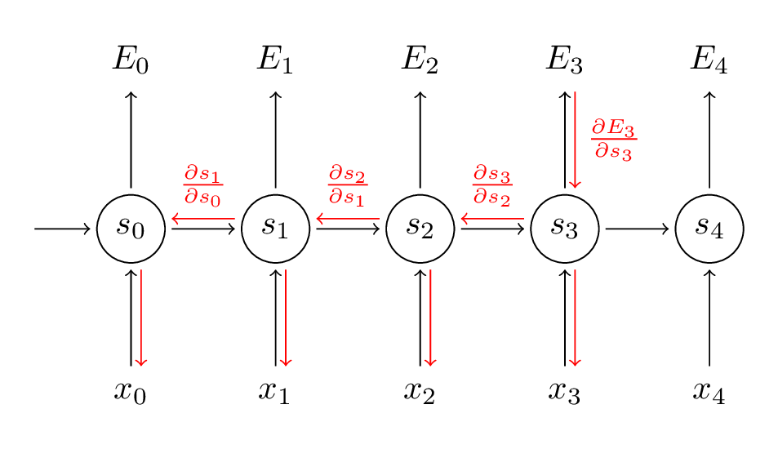
Source:(http://www.wildml.com/2015/10/recurrent-neural-networks-tutorial-part-3-backpropagation-through-time-and-vanishing-gradients/)
In the BPTT step, we calculate the partial derivative at each weight in the network. So if we are in time t = 3, then we consider the derivative of E3 with respect to that of S3. Now, x3 is also connected to s3. So, its derivative is also considered. Now if we see s3 is connected to s2 so s3 is depending on the value from s2 and here derivative of s3 with respect to s2 is also considered. This acts as a chain rule and we accumulate all the dependency with their derivatives and use it for error calculation.
In E3 we have a gradient that is from S3 and its equation at that time is:
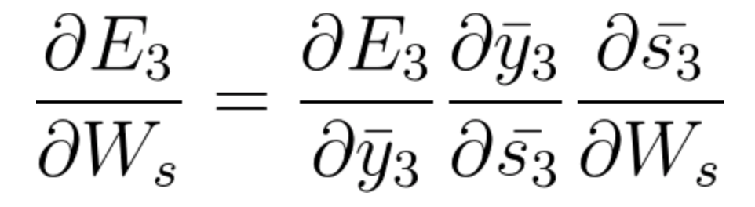
Now we also have s2 associated with s3 so,
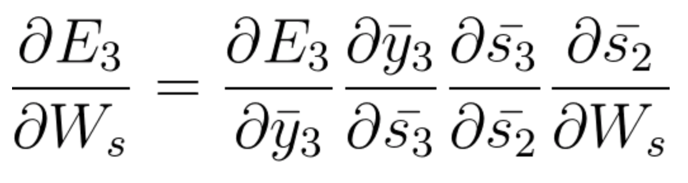
And s1 is also associated with s2 and hence now all s1,s2,s3 and having an effect on E3,
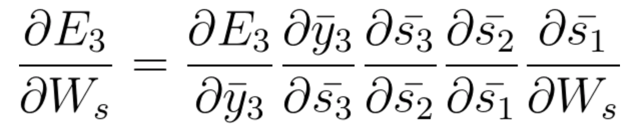
On accumulating everything we end up getting the following equation that Ws has contributed towards that network at time t=3,
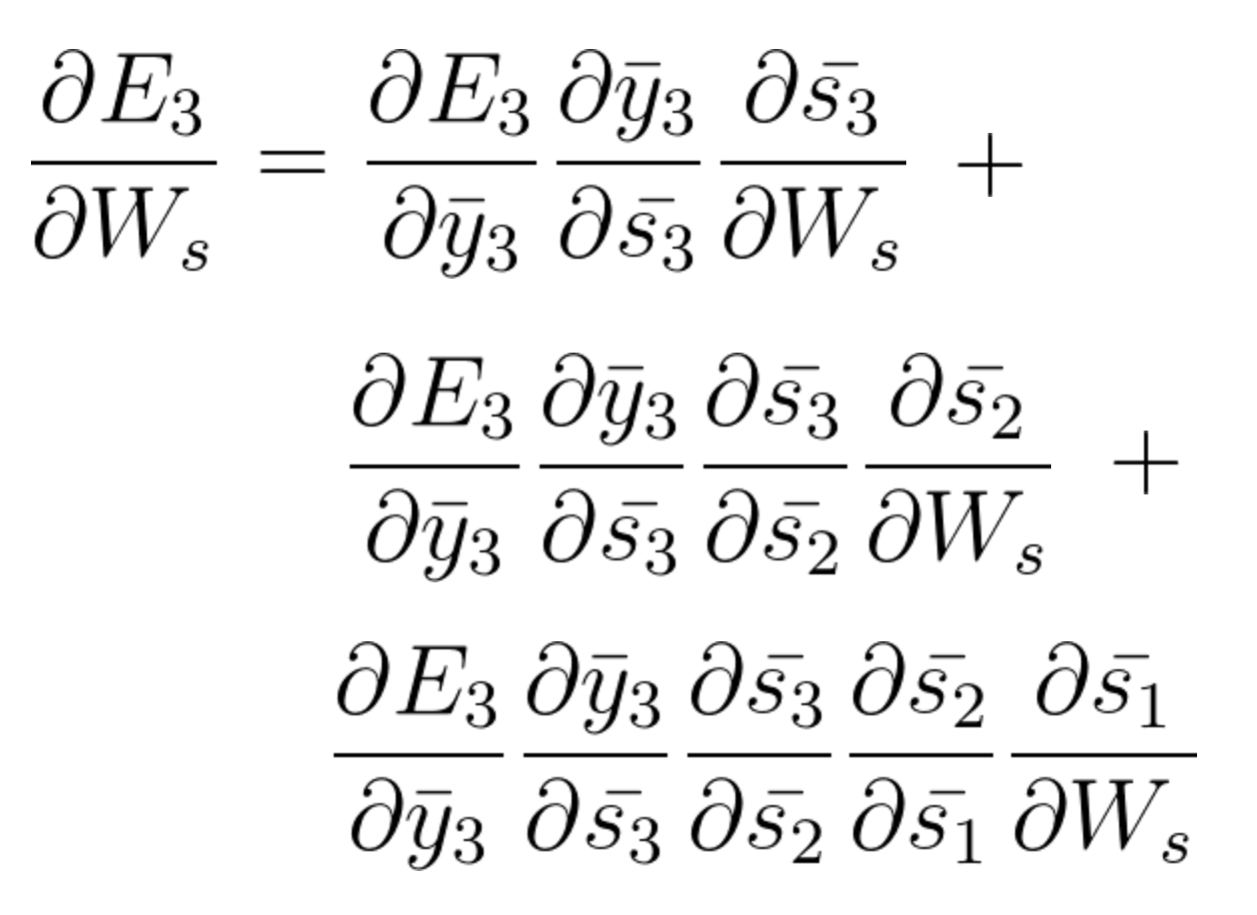
The general equation for which we adjust Ws in our BPTT network can be written as,
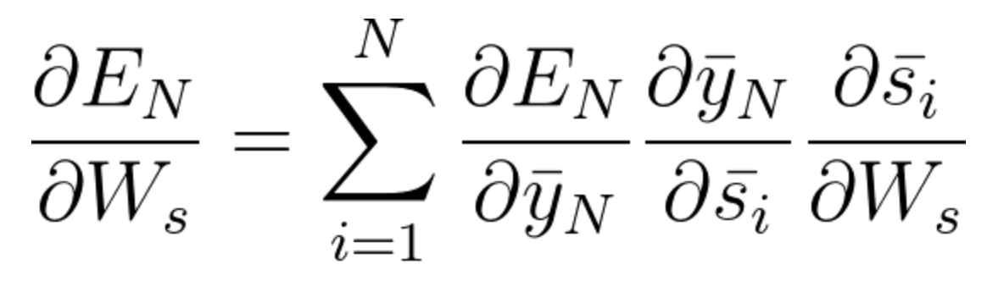
Now as we have noticed Wx is also associated with the network. So, doing the same we can generally write,
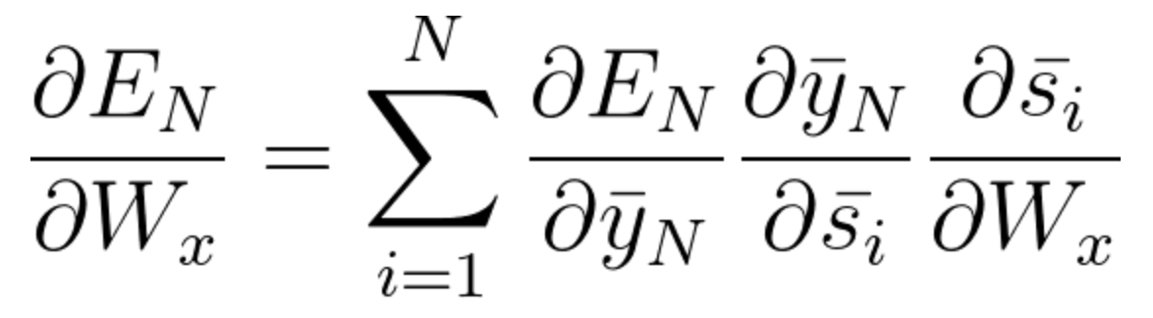
Now that you have understood how BPTT works, this is basically all about how RNN adjusts its weights and reduces the error. Now the main fault here is this is basically only for a small network with 4 layers. But imagine if we had hundreds of layers and at a time let’s say t = 100, we would end up calculating all the partial derivatives associated with the network and this is a huge multiplication and this can bring down the overall value to a very small or minute value such that it may end up being useless to correct the error. This issue is called Vanishing Gradient Problem.
Vanishing Gradient Problem
As we all know that in RNN to predict an output we will be using a sigmoid activation function so that we can get the probability output for a particular class. As we saw in the above section when we are dealing with say E3 there is a long-term dependency. The issue occurs when we are taking the derivative and derivative of the sigmoid is always below 0.25 and hence when we multiply a lot of derivatives together according to the chain rule, we end up with a vanishing value such that we cant use them for error calculation.
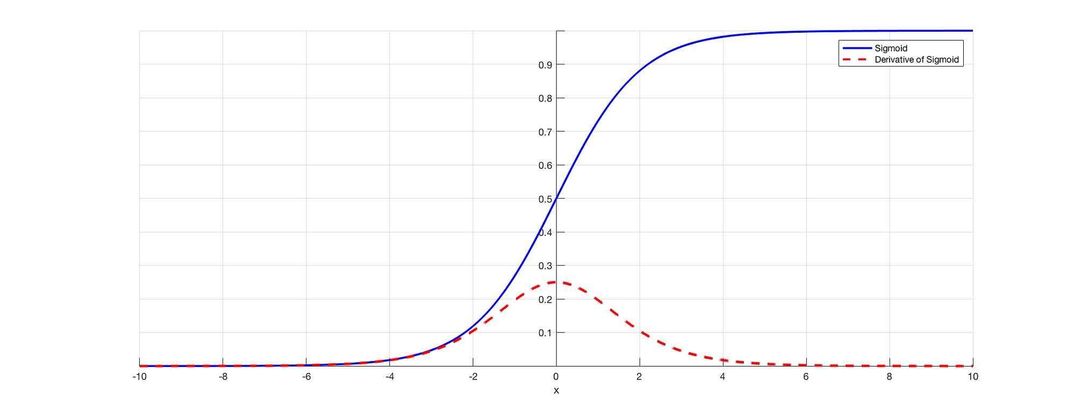
Source: (https://towardsdatascience.com/the-vanishing-gradient-problem-69bf08b15484)
Thus the weights and biases won’t get updated properly and as layers keep increasing we fell more into this and our model doesn’t work properly and leads to inaccuracy in the entire network.
Some ways to solve this problem is to either initialize the weight matrix properly or go for something like a ReLU instead of sigmoid or tanh functions.
Exploding Gradient Problem
Exploding gradients is a problem in which the gradient value becomes very big and this often occurs when we initialize larger weights and we could end up with NaN. If our model suffered from this issue we cannot update the weights at all. But luckily, gradient clipping is a process that we can use for this. At a pre-defined threshold value, we clip the gradient. This will prevent the gradient value to go beyond the threshold and we will never end up in big numbers or NaN.
Long term dependency of words
Now, let us consider a sentence like, “The clouds are in the ____”. Our RNN model can easily predict ‘Sky’ here and this is because of the context of clouds and it very shortly comes as an input to its previous layer. But this may not always be the case.
Image if we had a sentence like: “Jane was born in Kerala. Jane used to play for the women’s football team and has also topped at state-level examinations. Jane is very fluent in ____.”
This is a very long sentence and the issue here is as a human I can say that since Jane was born in Kerala and she had topped her state exam it’s obvious she should be very fluent in “Malayalam”. But how does our machine know about this. At the point where the model wants to predict words, it might have forgotten the context of Kerala and more about something else. This is the problem of Long term dependency in RNN.
Unidirectional in RNN
As we have discussed earlier, RNN takes data sequentially and word by word or letter by letter. Now when we are trying to predict a particular word we are not thinking about its future context. That is, let’s say we have something like: “Mouse is really good. The mouse is used to ____ for the easy use of computers.” Now if we can travel bidirectional and we can also see future context we may say ‘Scroll’ is the appropriate word here. But, if it’s unidirectional, our model has never seen computers so how does it know if we are talking about the animal mouse or computer mouse.
These problems are solved later using language models like BERT where we can input complete sentences and use the self-attention mechanism to understand the context of the text.
Use Long Short Term Memory (LSTM)
One way to solve the problem of Vanishing gradient and Long term dependency in RNN is to go for LSTM networks. LSTM has an introduction to three gates called input, output, and forget gates. In which forget gates take care of what information needs to be dropped going through the network. In this way, we can have short-term and long-term memory. We can pass the information through the network and retrieve it even at a very later stage to identify the context of prediction. The following diagram shows the LSTM network.
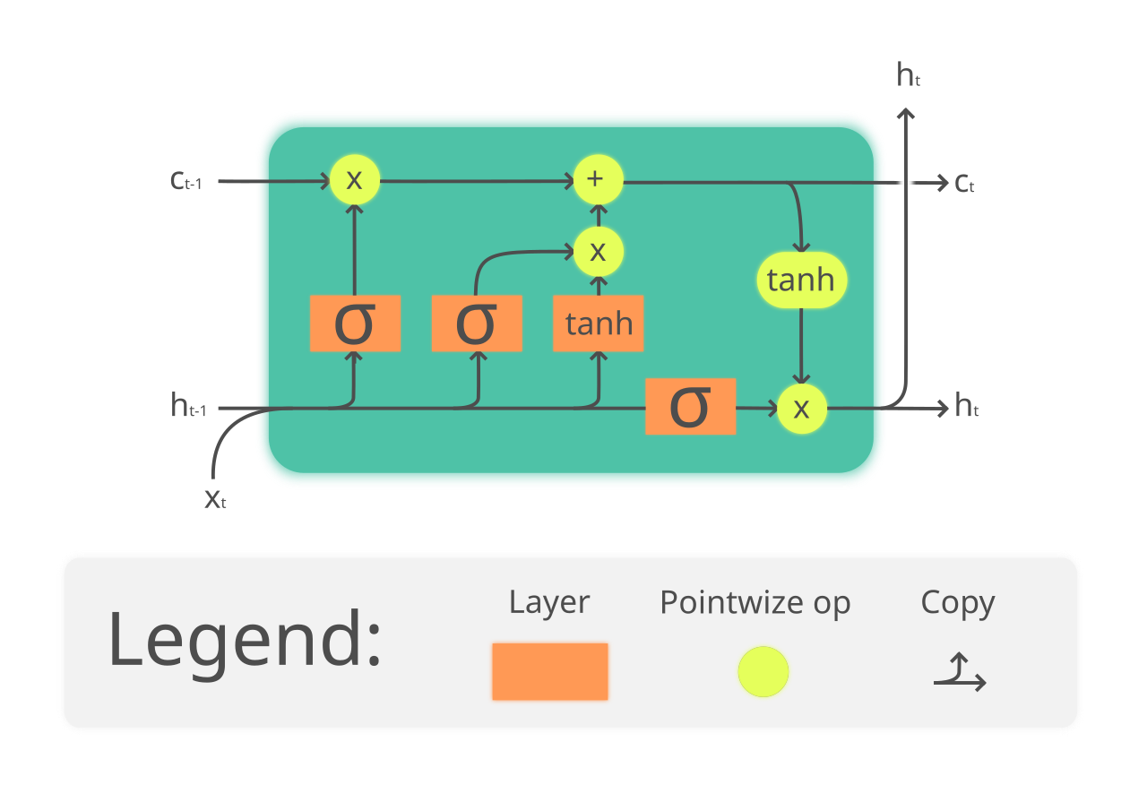
(https://en.wikipedia.org/wiki/Long_short-term_memory#/media/File:The_LSTM_Cell.svg)
Follow this tutorial for a better understanding and intuitive example of LSTM: https://towardsdatascience.com/illustrated-guide-to-lstms-and-gru-s-a-step-by-step-explanation-44e9eb85bf21
Hopefully, now you have understood the problems of using an RNN and why we have gone for more complex networks like LSTM.
References
1.http://www.wildml.com/2015/10/recurrent-neural-networks-tutorial-part-3-backpropagation-through-time-and-vanishing-gradients/
2. https://analyticsindiamag.com/what-are-the-challenges-of-training-recurrent-neural-networks/
3. https://towardsdatascience.com/the-vanishing-gradient-problem-69bf08b15484
4. https://en.wikipedia.org/wiki/Long_short-term_memory
5. https://www.udacity.com/course/deep-learning-nanodegree–nd101
6. Preview Image: https://unsplash.com/photos/Sot0f3hQQ4Y

